The instruction for authors – the title of the paper
(TNR 13 pt bold, 70 ptspacing before and 15 ptspacing after the last line)
(First Author) Name Surname (TNR 11 pt italic), Institution
(Second Author) Name Surname (TNR 11 pt italic), Institution
(Third Author) Name Surname (TNR 11 pt italic), Institution
(TNR 12 pt)
(TNR 12 pt)
(TNR 12 pt)
Abstract: This instruction provides directions for editing The Collection of Papersfrom The Belgrade Polytechnic.The authors are to edit their papers intechnical manner, following the instructions of this manual. The abstract should not contain more than 200 words, using the font TNR 12 pt. in italics. It should be written in one of more paragraphs, with alignment left and right, using the Serbian Latin keyboard layout. The abstract cannot contain tables, graphs, drawings and photos, nor citations from other authors.

Keywords: first keyword, second keyword (maximum of 5 – TNR 12 pt)

TITLE OF THE PAPER IN ENGLISH
(TNR 13 pt bold, 30 pt spacing before and 15 pt spacing after last line)
Abstract:Translate the abstract with up to 200 words in English
Keywords: first keyword, second keyword
(TNR 12 pt)

INTRODUCTION (The title of the chapter – TNR 12 pt BOLD)
(TNR 12 pt)
The complete paper (text, drawings, photographs, using author’s full name with affiliations), written inMicrosoft Word, font TNR, Serbian Latin keyboard layout, should be sent to: skup@politehnika.edu.rs. The maximum length of the paper for The Collection of Papers(including drawings, photographs, tables, literature, attachmentsand etc.) is limited to (6) pages in A4 size.
(TNR 12 pt)

TEXT FORMATING AND WRITTING.
(TNR 12 pt)
  - Text writing (The sub-chapter title – TNR 12 pt BOLD)
(TNR 12 pt)
All four margins in the paper should be intended by 2 cm. The text should be typed in Serbian (Serbian Latin) or in English, TNR font (Times New Roman) 12 pt, using single spacing (1). Pages should not be marked with numbers. Abbreviations and acronyms must be defined with the first appearance in text, regardless of their definition in the abstract. Commonly known abbreviations such as MKS, SI, TV, etc. do not need to be defined.

  - Expressions writing, tables and picture adjustments
(TNR 12 pt)
Equations are to be prepared with Word’s Equation Editor or by Math Type. Parameters for equation typing are the size 12 pt TNR; subscripts and superscripts 10 pt, sub-subscripts are 8 pt. Numbers, parentheses and capital Greek symbols are notitalic. All Latin type variables A, B, X, Y, a, b, x, y,as well as small Greek symbols α, β, γ, are italic, and the vector and matric symbols Γ, A, X, are in TNR Bold. Operators and functions are also notitalic, e.g.

Formulasare cited in angular parentheses, e.g. (1) and should be marked with a number to the right edge of the text.
$\sin\left(\frac{a}{b}\right),\ln\left(x\right),max,min,\lim_{x→0}{f\left(x\right)}$ (1)

Symbols of chemical elements and units of measure for physical quantities are to be written using ’’subscript/superscript’’ options and are also not italic, for example:

C₂H₂ + O₂⇒ 2C + H₂ + O₂ + 0.255 MJ/mol (2)

Images and diagrams are to be centred.The text in images and diagrams must be readable, therefore font TNR size 9 or 10 should be used. Every image/diagram to is to be marked with a number below, with the addition of short name (description), with previous reference in the text. Be sure to specify the source below the image / diagram. If the source is a website, then the link needs to be shortened (use a short link).

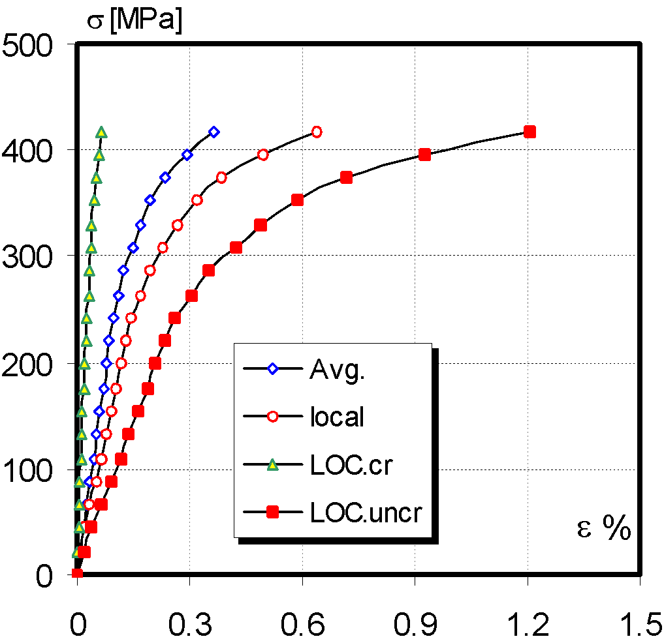
Image 1.Dependence of voltage-deformation TP1 (TNR 12 pt)
Source:specify the image source (TNR 10 pt)

Images should be provided in separate files, using TIF, BMP, WMFformat, ..., in the case of additional editing, or in the CDR or PSD format, if they were done in Corel or Adobe Photoshop. This particularly pertains for photographs.
Tables should be centered. The size of tables and the text in them need to be readable, therefore the text should be written in TNR font 12 pt. and centred in table columns. A number and a short name (the source of the table should be indicated in brackets) is to be added above each table, with the previous reference to the table in the text.If the source is a website, then the link needs to be shortened (use a short link).

Table example:

Table 1.Geometric data (mm) (TNR 12 pt)
Source:specify the data source (TNR 10 pt, italic)
 |  |  | Velika- Large | Mala- Small
Površinska prslina | Surface crack |  | LSC | SSC
Dubina prsline | Crack depth | a | 2.5 | 1
Dužina prsline | Crack length | 2c | 8 | 8
Vrh prsline | Crack tip | r | 0.1 | 0.1
Dužina MŠ | WM length |  | 2 | 2

- CONCLUSION
(TNR 12 pt)
Papers written in an inadequate form will be returned for additional editing. The original as-received document may be additionally formatted (editors’ choice).
(TNR 12 pt)

LITERATURE
(TNR 12 pt)
Literature should be specified at the end of the paper, in a specific, non-numerical part. References in the text should be cited alphabetically and chronologically, using square breakers, for example: Author’s surname, first letter of the name, the year of publication (TNR, small letters 11 pt), and in continuation, the full title of the work, the name of the journal or other source, the volume and number of the journal, pagination. When making references, the numbers in brackets should be written within a sentence eg [3] or at the end of the sentence eg [4,5,6].

Examples of referencing literature:

[1] Surname, N., Surname, N.: Name of Book (in Italics), Publisher, ISBN, Place of Publication, (YYYY)
[2] Surname, N. &Surname, I.: Name of paper or Chapter, In Name of Book (in Italics), Publisher, ISBN, Place of Publication, (YYYY), pp. xxx-yyy
[3] Surname, N.; Surname, N. &Surname, N.: Title of conference paper, Proceedings of xxx xxx, Surname, N. (Ed.), pp. xxx-yyy, ISBN, conference location, Month and Year, Publisher, City, (YYYY)
[4] Surname, N.: Name of Paper, Name of Journal (in Italics), Vol. (YYYY) No., pp. xxx-yyy, ISSN

The example of referencing web pages:

[1] Narodna Banka Srbije, 2014. Vlasnička struktura i bilans stanja/uspeha banaka. [Internet] Available on: http://www.nbs.rs/internet/cirilica/50/50_5.html (Accessed: 01.05.2019.)

NOTE: THE AUTHORS AREIN OBLIGATION TO PROVIDE A SIGNED STATEMENT ON THE COPYWRITE OWNERSHIP AND THE ORIGINALITY OF THE MANUSCRIPTS (scanned document)

First author email (TNR 10 pt)
Second author email (TNR 10 pt)
Third author email (TNR 10 pt)

